
Story

Date | 24 September 2024
Team ID | desaisabiha1212@gmail.com
Project Name | Online Food Delivery Analysis Using Tableau
Maximum Marks | 5 Marks

By using Stories in Tableau, we can present data analysis in an interactive and engaging way. A Tableau Story is a sequence of dashboards and visualizations that helps viewers understand important findings, trends, and insights step by step.
In this project, a Tableau Story is created using online food delivery survey data. It presents customer preferences, spending patterns, food delivery platform usage, and customer ordering behaviour in a clear and organized manner.

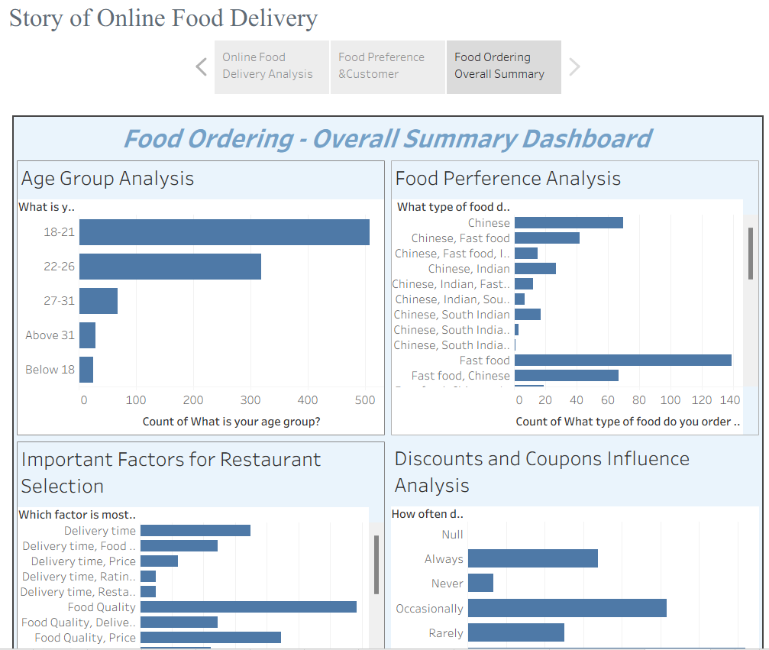

Observations:
- Customer Age Groups: The analysis shows the different age groups of customers using online food delivery services.
- Spending Patterns: The dashboard helps understand customers' spending on a single food order.
- Food Preferences: It identifies the types of food ordered most frequently by customers.
- Platform Usage: It compares the food delivery platforms preferred by customers.
- Customer Behaviour: It highlights ordering reasons, restaurant selection factors, common delivery problems, and the influence of discounts and coupons.

Activity 2:
Publish Story on Tableau Public and Paste Public Link Below
Tableau Public Story Link:
https://public.tableau.com/authoring/Online_Food_Delivery_Analysis/Sheet1/Story%201#1

